People Management in Snitch: The Role of Personality and Values in
Building a Modern Fashion Brand
1.Course: People Management
Prepared by:

MSE25011 CHIRANJEEVI KUMBHAR
MSE25016 ARPITA SINGH
MSE25018 OM PRASAD PANI
MSE25020 RADHA TELI

Institution: IIIT LUCKNOW
Date: 30 OCOTOBER ,2025
ABSTRACT

Every successful organization revolves around people management. It can be described as the art and science of handling, motivating and developing workers in a bid to attain individualized goals expansion and company objectives. People management in the contemporary business is more than administrative control, it is about the understanding of the human behavior, developing talent, etc and balancing individual standards and corporate goals.
People management is increased in the creative industries such as fashion.
Innovation, flexibilities, and teamwork that make the industry successful require workers of different personalities and high expectations of the brand values.
The case study is about Snitch, an Indian fashion brand with rapidly growing popularity, and its attitude towards personality and organizational values, which contributed to its identity, culture.
and success. It will examine management philosophy, recruitment and culture building practices, leadership style and how the people management has been aligned with its brand image in Snitch..

Company Overview
3.1 About Snitch
Snitch was established by Siddharth Dungarwal as a business-to-business(B2B) apparel supplier in Bengaluru, India in 2018. It shifted to a direct-to-consumer (D2C) in a few years, and targeted bold, trendy menswear to the young in India fashion-conscious demographic.The company became widely known when it appeared in Shark Tank IndiaSeason 2, where it impressed the investors with its good online presence, youthful atmosphere and.consistent sales growth. Snitch has today developed a customer base, which is loyal due to its provision of stylish products blended between streetwear and casual luxe, affordable, and experimental male clothes.
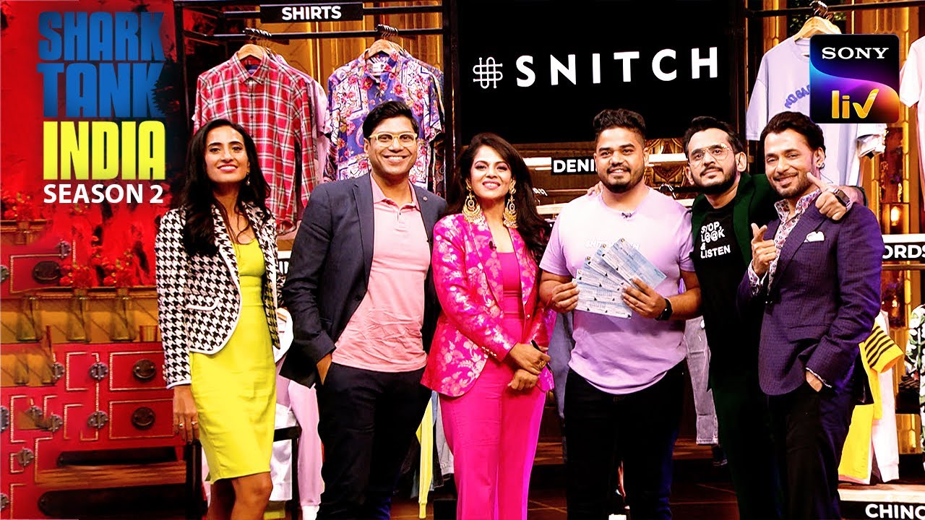
.3.2 Mission and Vision
Mission: To reinvent men fashion in terms of creativity, comfort, and confidence.
Vision: To be the best digital first men fashion brand based on innovation in India.
authenticity, and inclusivity.

3.3 Core Values
The core values of Snitch make it a successful company:
Creativity/Innovation- The Proposal to experiment in fashion and marketing.
Integrity and Authenticity - Keeping customers and employees in the know.
Inclusivity and Teamwork - Advocating a teamwork culture.
Customer Obsession - Building and providing through customer feedback.

Theoretical Framework: People Management, Personality, and Values
4.1 People Management
The human resource practices such as hiring, training, etc. are integrated into people management. motivation, and communication, the leadership and emotional intelligence. This is aimed at making employees feel appreciated, involved, and in line with the mission of the company. Proper people management enhances productivity, lowers turnover and boosts company culture.
4.2 Personality in the Workplace
Personality is defined as the recurrent patterns of behavior, feeling and thought which influences how individuals relate with other people. The Big Five traits are commonly used by psychologists to define personality :
1 Openness to experience- Creativity and curiosity.
2 Conscientiousness- Reliability and discipline
3 Extraversion- Sociability and enthusiasm
4 Agreeableness- Cooperation and kindness
5 Emotional Stability- Capacity of coping with stress and difficulties.
Trait such as are important in workplaces where creativity and collaboration are vital such as Snitch. Top-value is openness, extraversion, and agreeableness.
4.3 Values in Organizations
Values are common ideas on what is right or desired or what matters. They shape decision making, team work and behavior. Organizational values are mutual when shared by employees .organization, they are more engaged and committed. Innovation, inclusion, authenticity are not just the slogans at Snitch, they are the values. they direct the recruitment, management, and daily communication.

Personality in Snitch’s Workforce
5.1 Hiring for Personality Fit
The philosophy of hiring applied by Snitch works on attitude and not experience. The brand seeks brash, outspoken, and vigorous people or those who are not afraid to defy convention characteristics that are reflective. Snitch's market personality. Recruiters measure creativity, openness to during interviews. feedback, and interest in fashion and not just technical qualifications.
As an illustration, young professionals who belong to non-traditional work environment are often part of the marketing team. targets, such as social network fans and creative freelancers. This diversity innovation is driven by of personality types.
5.2 Team Dynamics
Snitch encourages collaboration between departments—design, digital marketing, customer engagement, and operations. The teams are small and agile, allowing personalities to blend rather than clash. The organization practices open communication, where every member, regardless of role, can contribute ideas.
Team meetings are informal yet productive, encouraging debate and imagination. The extroverted personalities of brand managers complement the meticulous, conscientious nature of designers and analysts, ensuring a healthy balance between creativity and precision.
5.3 Encouraging Authenticity
The brand name of Snitch is based on self-expression -Wear Your Personality. The same philosophy stretches to the employees. Managers promote genuineness in work, between lax dress codes and loose brainstorming. Employees feel comfortable exchanging unconventional thoughts, with the knowledge that they are not going to get ruled out because they are different Circuit Break.

5.4 Personality Development Initiatives
The company conducts leadership, communication and emotional workshops intelligence. Cultural onboarding is provided to new employees in order to learn. The tone of Snitch is contemporary, sure but friendly. Such initiatives assist in bringing it to parity energetic personalities of the company and goals.

Organizational Values and Culture
6.1 Innovation as a Core Value
Innovation at Snitch is not just product design but rather marketing, operations and so on.and internal processes. The teams are advised to be innovative regarding campaigns, experiment. technologies, and make calculated risks. As an example, the premature use of influencer marketing on Instagram and Reels by Snitch. assisted in making it relevant with Gen Z audiences. On the inside, the management awards. innovative problem solving, not output.
6.2 Integrity and Transparency
The internal culture of Snitch is based on honesty and accountability. Leadership shares freely on business objectives, issues and performance. Regular town-hall meetings enable the workers to express ideas and feedback. There is also transparency in the customer engagement- support and employee. marketing are trained to deal with complaints in an empathetic as well as professional manner. strengthening the integrity value.
6.3 Inclusivity and Team Spirit
Snitch is of the view that diversity is the key to creativity. The staff consists of individuals of different types. geographical areas, languages, and education level. This is diversity that drives cross-cultural. innovation of design and marketing. Leadership behavior also portrays inclusivity-there is little hierarchy, and the employees are minimal in number.can go directly to the top management with ideas or concerns.

6.4 Customer-Centric Mindset
All the workers at Snitch are trained to put themselves into the mind of the customer. From product designers to packaging personnel, everybody knows what role he/she plays in. customer satisfaction. This value is common ground which makes the internal culture and external brand image remain aligned.

Leadership and HR Practices
7.1 Leadership Style
An example of participative leadership is Siddharth Dungarwal, the founder. He maintains a strong bond with his workers and appreciates free communication. His leadership style is a combination of transformational (inspiring vision) and democratic (seeking input from). others) approaches. According to the employees, the leadership of Snitch was visionary and approachable. Decisions are created as a team, and achievements are made to be shared, which strengthens the one team feeling.
7.2 Employee Motivation and Retention
At Snitch, motivation depends on recognition and opportunity. High-performing employees are recognized using in-house shout-outs, bonus, and developmental opportunities. Snitch has flexible working hours and since the fashion industry is a very dynamic one. innovative freedom to avoid exhaustion. Informal gatherings are also made by the company and festivals to enhance team building..
7.3 Learning and Development
Snitch ties up its money in skill development programs--particularly, digital marketing, data analytics, etc. and fashion trend analysis. Managers motivate the staff to undertake online qualifications. and workshops, encouraging life-long learning. These opportunities do not only improve on individual competence but they also build loyalty, as employees will feel that the company invests in them.
7.4 Managing Young Talent
Snitch has young workforce, with the average age of its employees being below 30 years old, representing the youth in India. Managing this generation needs to be flexible, purposeful and have a sense of belonging. Snitch does this by keeping the culture of the company relaxed yet collaborative and maintaining clarity performance expectations.

Challenges and Opportunities
8.1 Managing Creative Personalities
Although creativity is the best asset of Snitch, it can be difficult to cope with strong as well individual personalities. Disagreements in opinions, artistic orientations, or campaign concepts. sometimes create conflicts. The HR mediates through the open discussions and the conflict resolution training.
8.2 Maintaining Culture During Growth
Snitch has to continue its startup-style energy and personalized leadership as it grows. becomes harder. Rapid scaling causes a structural change and thus may dilute the original culture. The firm is also in the process of formalizing its core values to preserve them as it grows in the competitive market.
8.3 Retaining Talent in a Competitive Market
D2C brands such as Bewakoof, The Souled are numerous in the Indian fashion industry Store, and H&M India. Young workers tend to change their jobs to better remuneration or innovative freedom elsewhere. Snitch can solve this problem by providing clear career development, creative benefits, and good working conditions.
8.4 Opportunity for Global Expansion
Snitch has a good online following, which will provide it with an opportunity to expand internationally. This expansion will need cross cultural management skills, diversity training and adjustment of people management to international standards.

Findings
Having reviewed the people management practices of Snitch, the following important insights can be made:
Brand-Employee Personality fit: The people of Snitch are brand ambassadors of Snitch. Their innovation, passion and receptiveness are representative of the young and daring nature of the company.
Values Shape Behavior: Innovation and inclusivity are inherent factors in making decisions at the company communication. The staffs feel motivated to act on their own since their values are similar with those of the brand.
Leadership Facilitates involvement: In participative leadership, there is ownership and accountability by virtue of flat hierarchy. Employees feel that they will be noticed and appreciated, and it enhances motivation.
Centricity to customers reinforces loyalty: The common ideology of customer satisfaction brings harmony among departments to be united stable brand experience.
Requirement of Systematic HR Organisation: Although informal culture is a strength, the culture of the informal type will need to be more structured as Snitch expands Performance appraisal, conflict management and long-term retention HR systems.

Recommendations
1 Present Assessment Personality Instruments:During recruitment, use of standardized personality tests, so that the candidates fit in both. role demands and organization culture.
2 Design Value Reinforcement Program:Hold bi-monthly seminars at which the teams will speak about how they practice company values in daily work.
3 Mentorship Programmes:Assign senior and junior employees to learn and transfer knowledge and develop leadership development.
4 Extend Diversity Initiatives:Support gender and regional diversity in order to introduce new ideas into design andstrategy.
5 Formalize HR Policies: The company has transparent feedback, rewards and career advancement schemes as it expands will aid in maintaining its creative culture.
6 Invest in Employee Wellness: Offer psychological assistance, artistic retreats, and health services to manage.the fashion world, which is very fast-paced.
7 Cross-Functional Projects: Promote mutual work between departments in the new product introduction or campaign,
cultivating teamwork and innovation.

Conclusion
The rise of Snitch as a small apparel company to one of the top D2C menswear brands. underlines the strength of good people management. The company's success is not , It is only after all a by-product of its sense of fashion--but its capacity to develop personalities that identify with its brand values.Through the establishment of a setting where creativity is matched with discipline, individuality is matched and organizational objectives, Snitch illustrates that management of people is not concerned with dominion but over relationship. The problem in this will be to sustain this culture of authenticity and innovation as it continues to grow and also providing structure and scalability. In the case that Snitch remains personality-balanced that has solid organizational principles, it is bound to be not only a fashion role model.with benchmarking people-centric management.

References
Snitch Official Website: https://www.snitch.co.in
Interviews with Siddharth Dungarwal, Founder, YourStory (2023)
Economic Times Startup Coverage on Snitch, 2023
Shark Tank India Season 2, SonyLIV Episode
Robbins, S. P. & Judge, T. A. (2019). Organizational Behavior. Pearson Education.
SHRM (Society for Human Resource Management) Articles on People Management and Workplace Values


